# CONSOLIDATED EXAM QUESTIONS

# CHEMICAL REACTIONS

Contents

CONSOLIDATED EXAM QUESTIONS 1

CHEMICAL REACTIONS 1

Syllabus 2

Molar Mass – 9.1-9.3 3

2017 S1 3

2017 S2 3

2020 S1 3

2020 S2 3

2023 S1 3

2023 S2 3

Percentage Composition - 9.4 4

2017 S1 4

2017 S2 4

2020 S1 4

2020 S2 4

2023 S1 4

2023 S2 4

Thermochemical Equations - Exothermic and Endothermic Reactions, Enthalpy – 10.1-10.2 6

2017 S1 6

2017 S2 8

2020 S1 9

2020 S2 9

2023 S1 10

2023 S2 10

Fuel and Combustion Reactions – 11.1-11.3 11

2017 S1 11

2017 S2 15

2020 S1 15

2020 S2 15

2023 S1 15

2023 S2 15

Other Chemical Reactions 17

2017 S1 17

2017 S2 17

2020 S1 17

2020 S2 17

2023 S1 17

2023 S2 17

# Syllabus

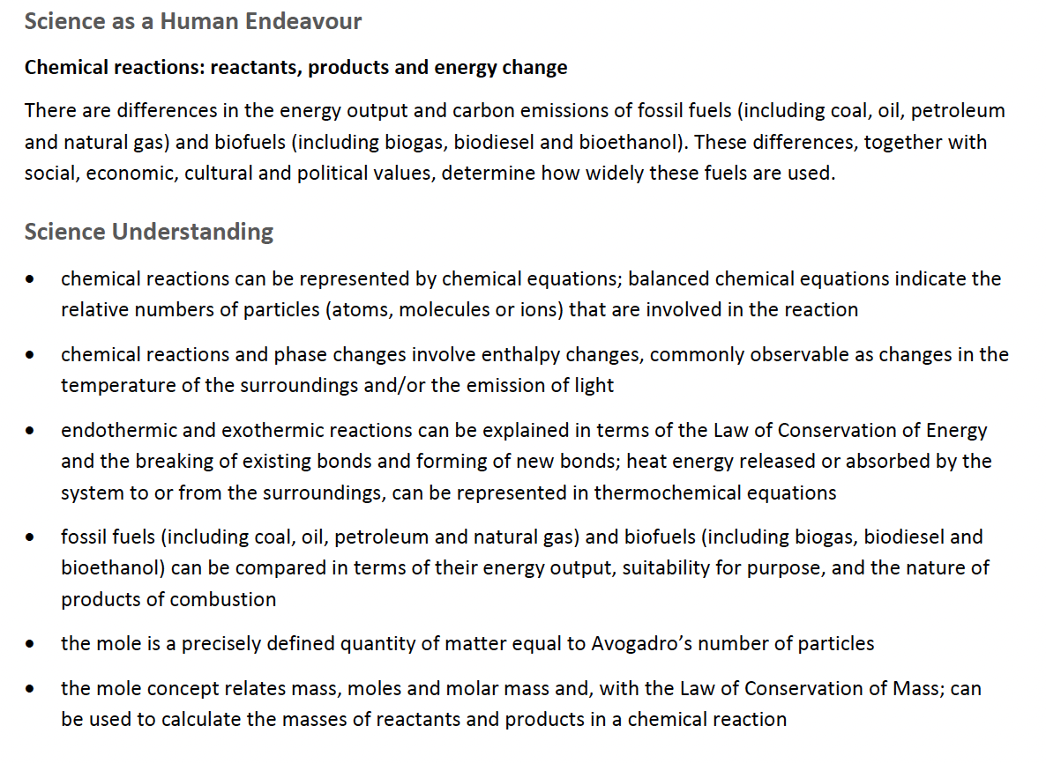

# Molar Mass – 9.1-9.3

## 2017 S1

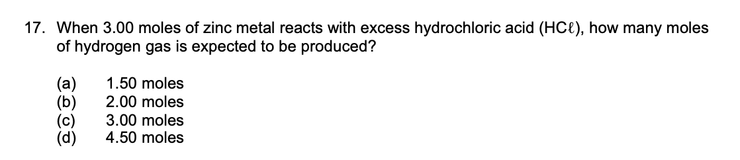

## 2017 S2

## 2020 S1

## 2020 S2

## 2023 S1

## 2023 S2

# Percentage Composition - 9.4

## 2017 S1

## 2017 S2

## 2020 S1

## 2020 S2

## 2023 S1

## 2023 S2

# Thermochemical Equations - Exothermic and Endothermic Reactions, Enthalpy – 10.1-10.2

## 2017 S1

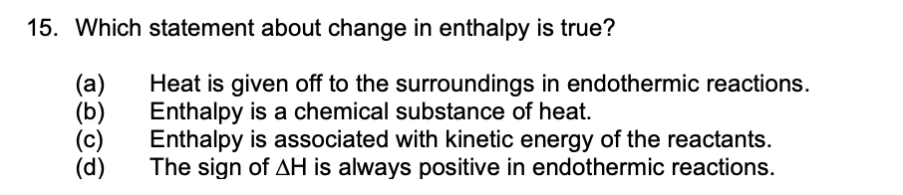

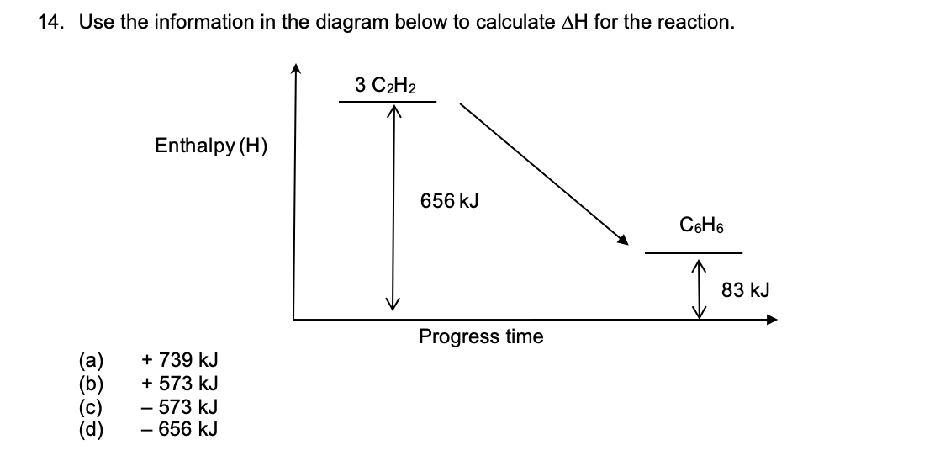

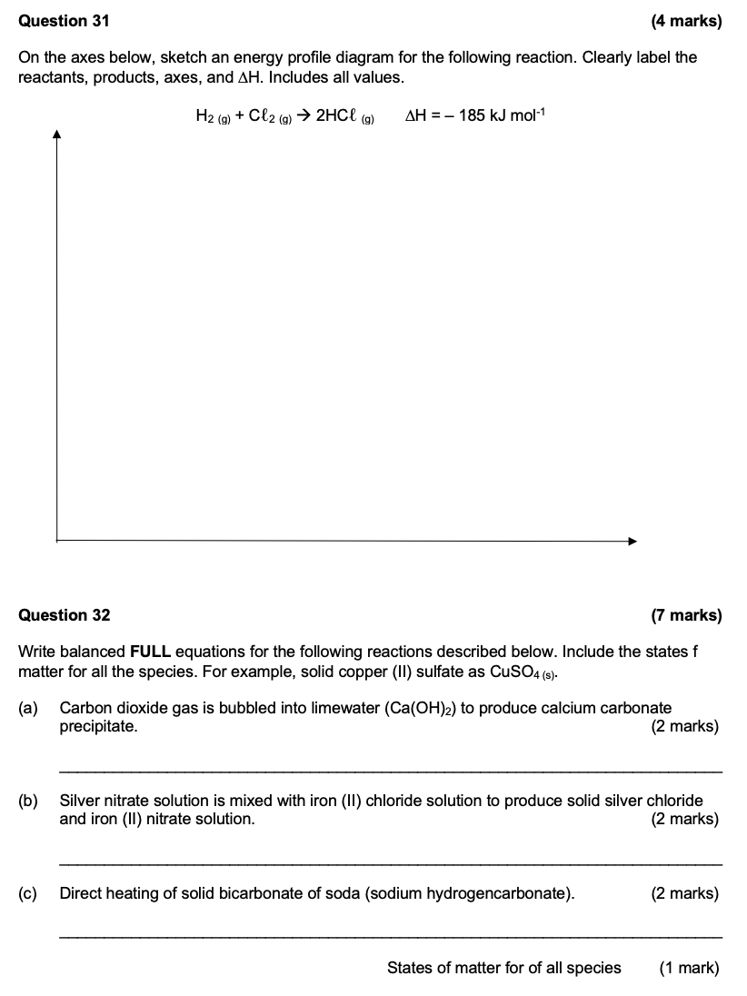

## 2017 S2

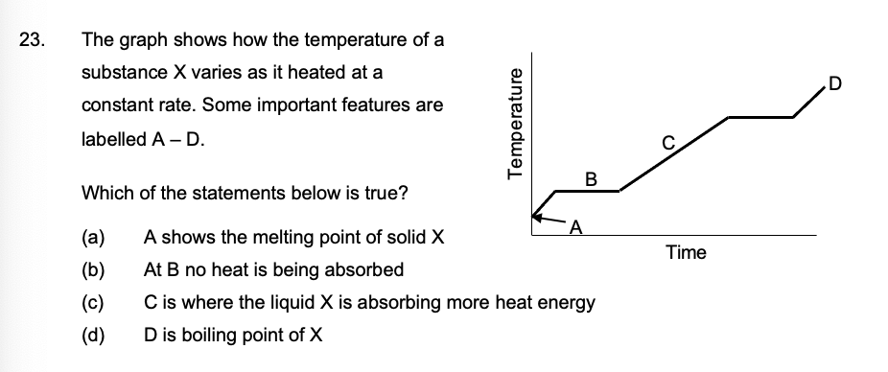

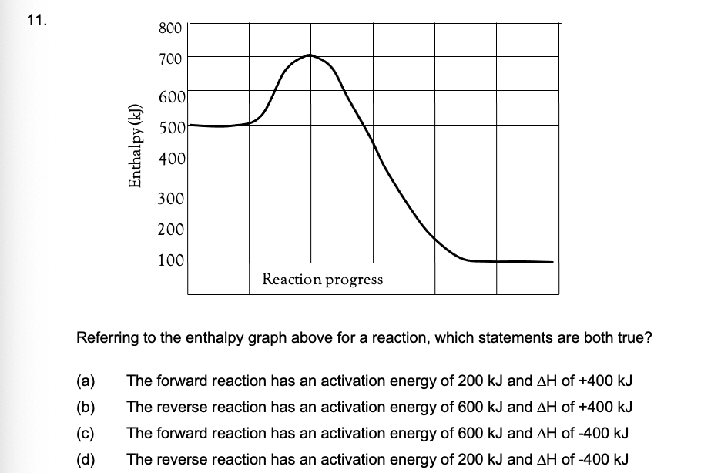

## 2020 S1

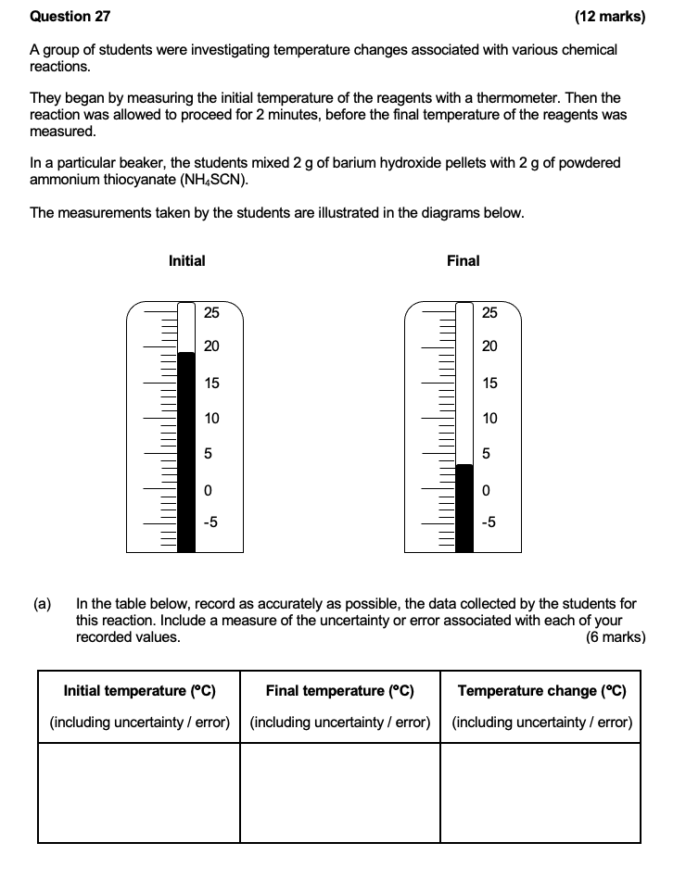

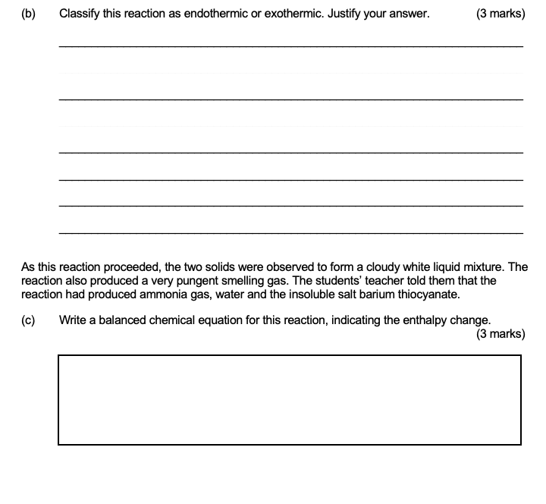

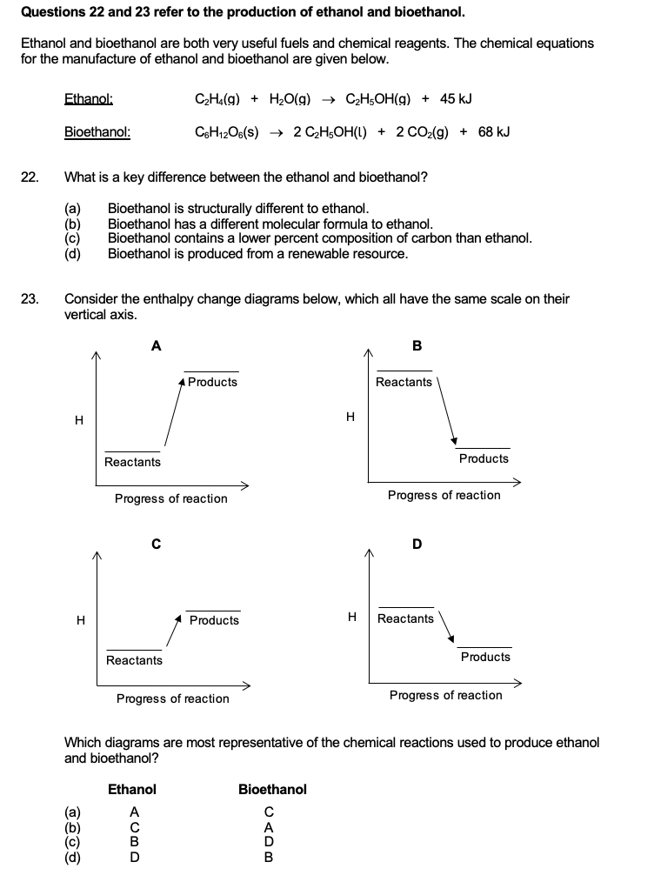

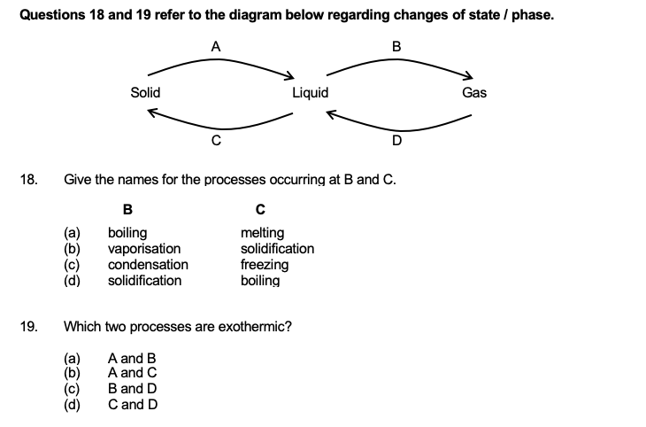

## 2020 S2

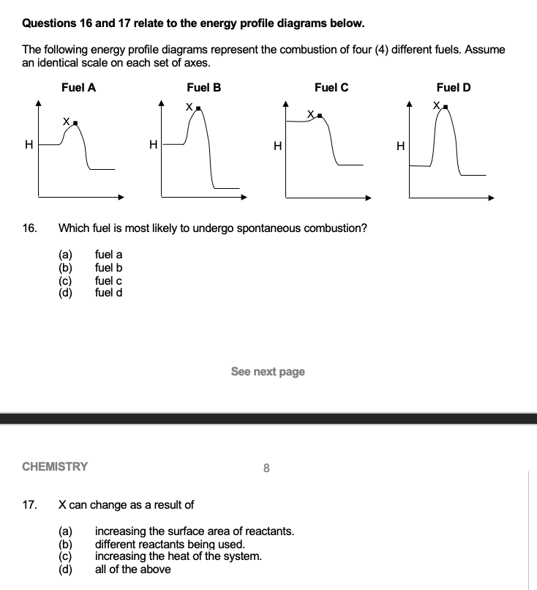

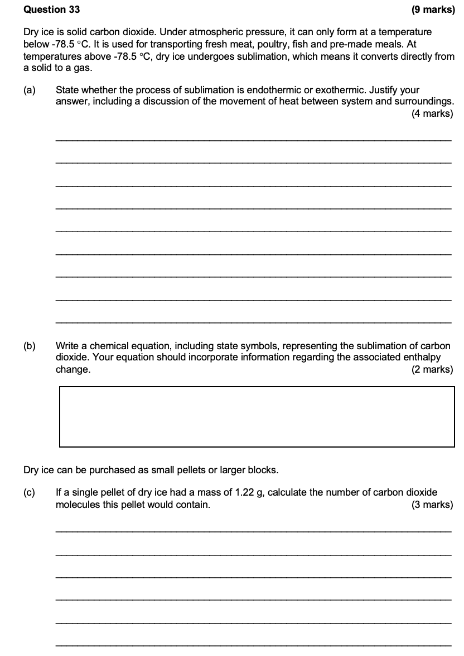

## 2023 S1

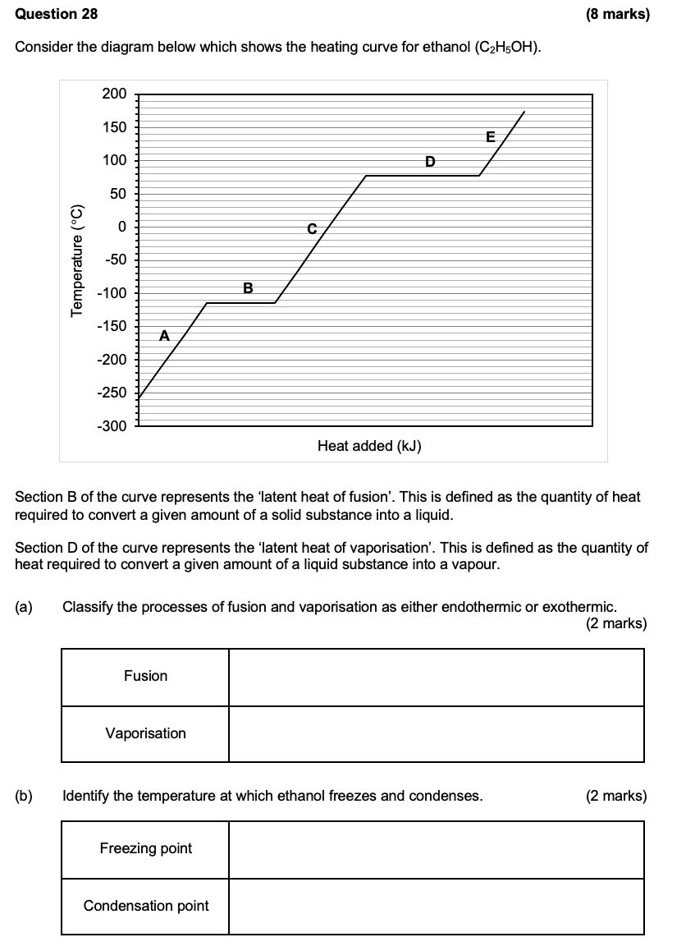

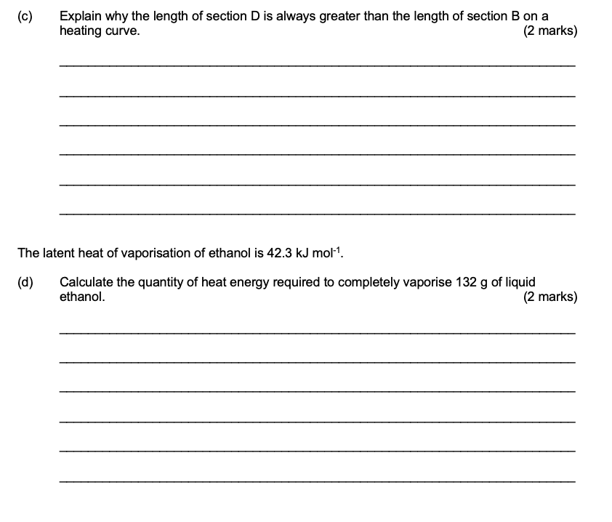

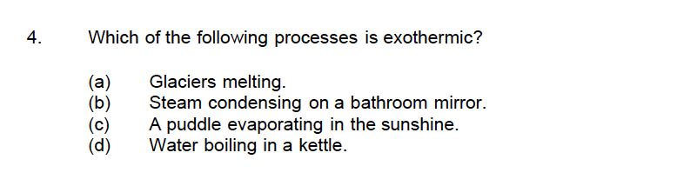

## 2023 S2

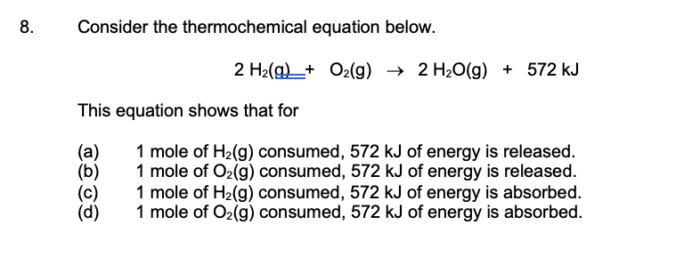

# Fuel and Combustion Reactions – 11.1-11.3

## 2017 S1

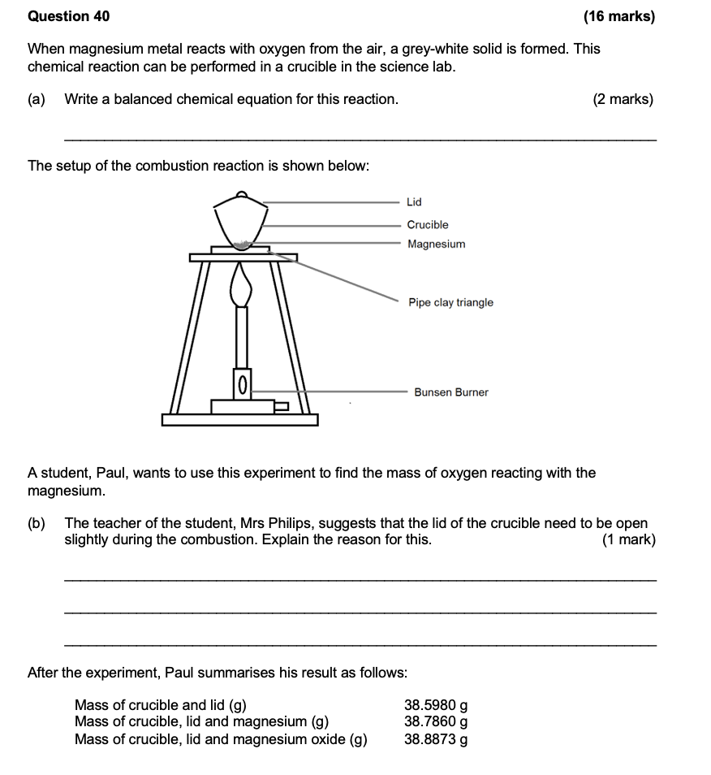

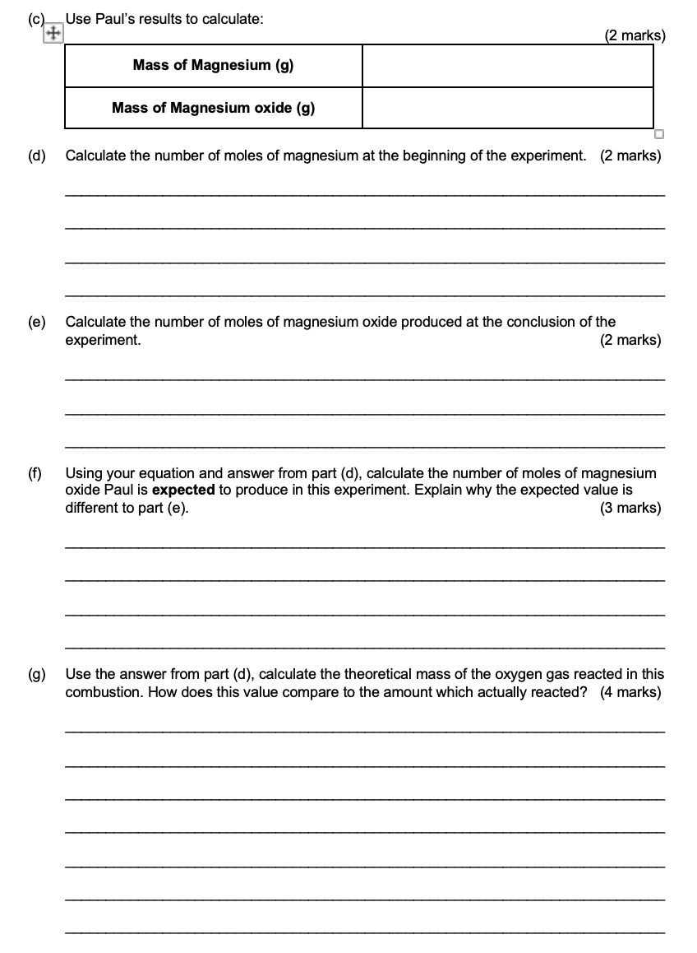

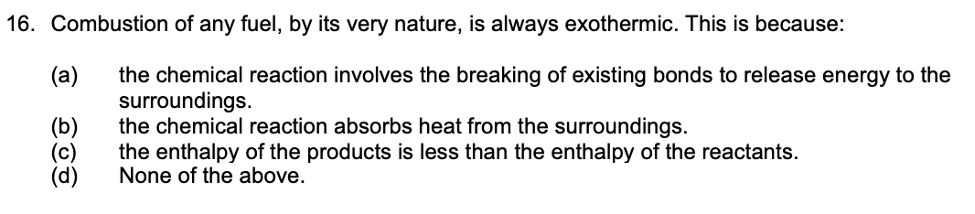

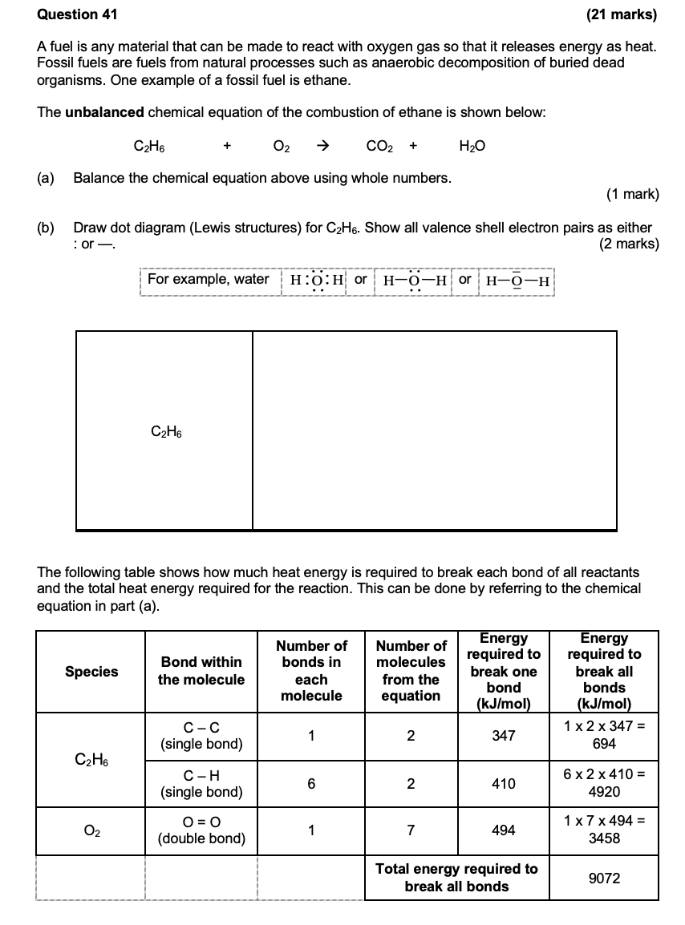

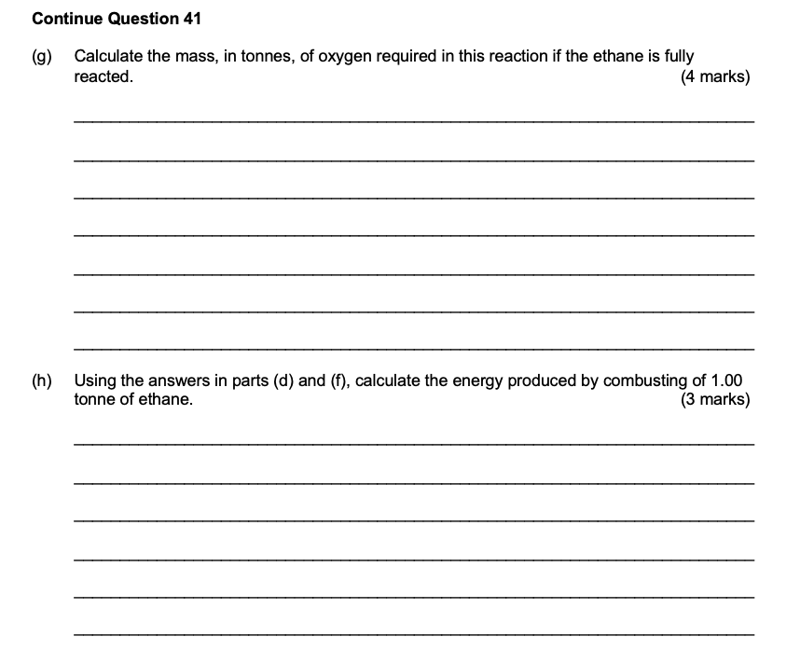

## 2017 S2

## 2020 S1

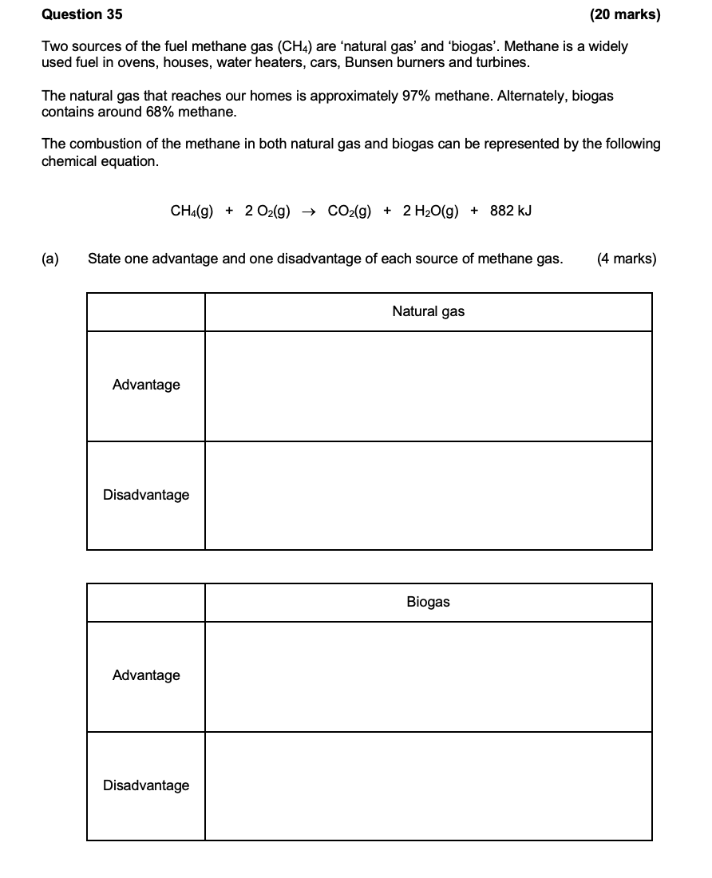

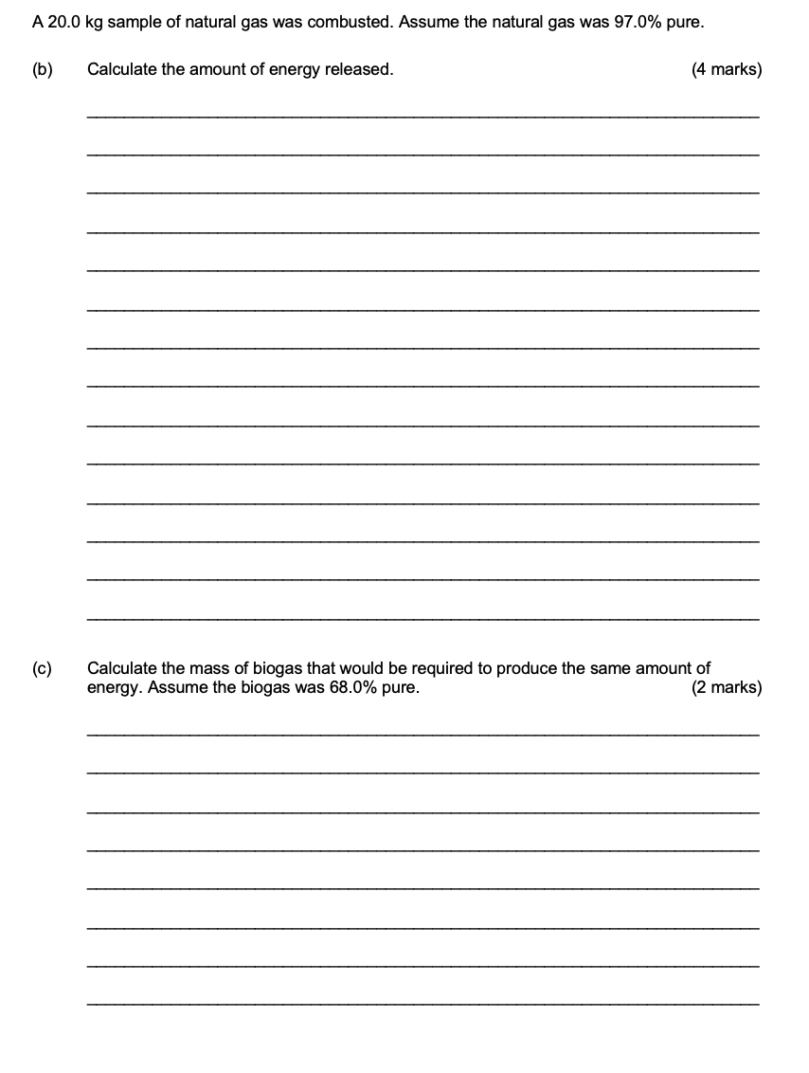

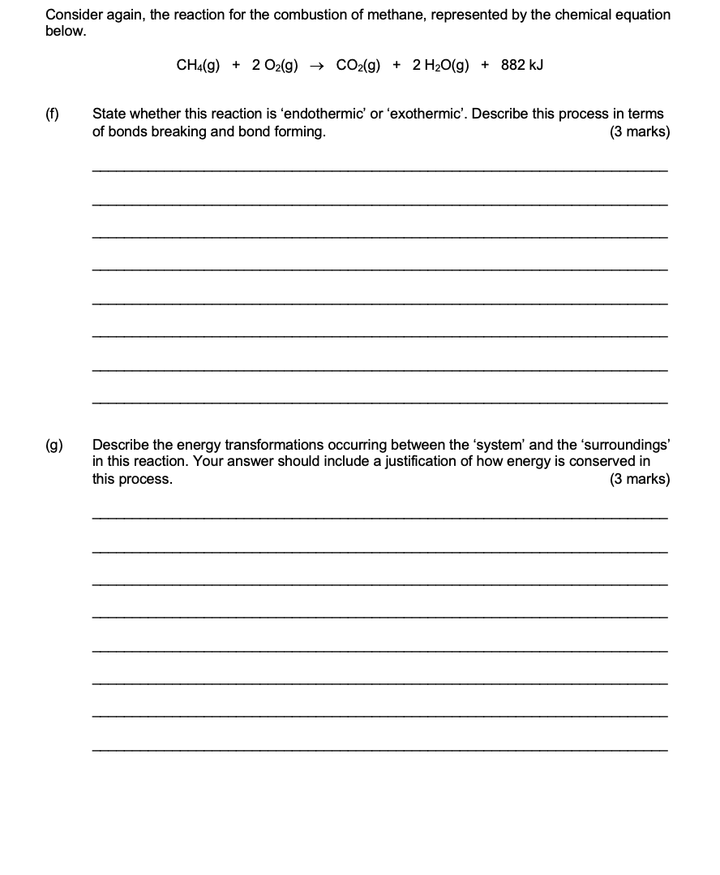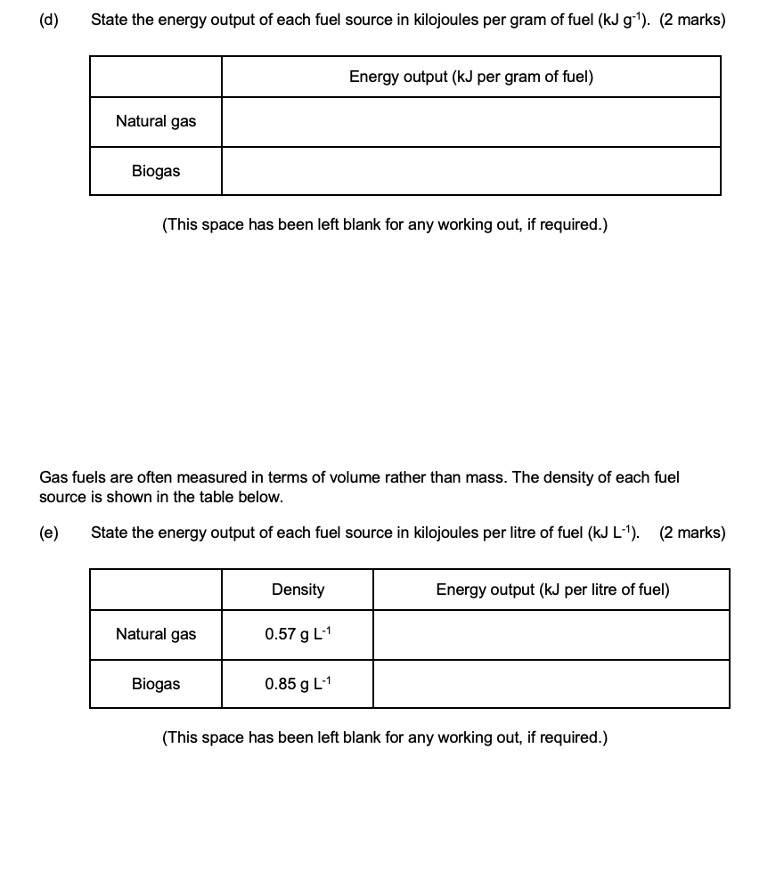

## 2020 S2

## 2023 S1

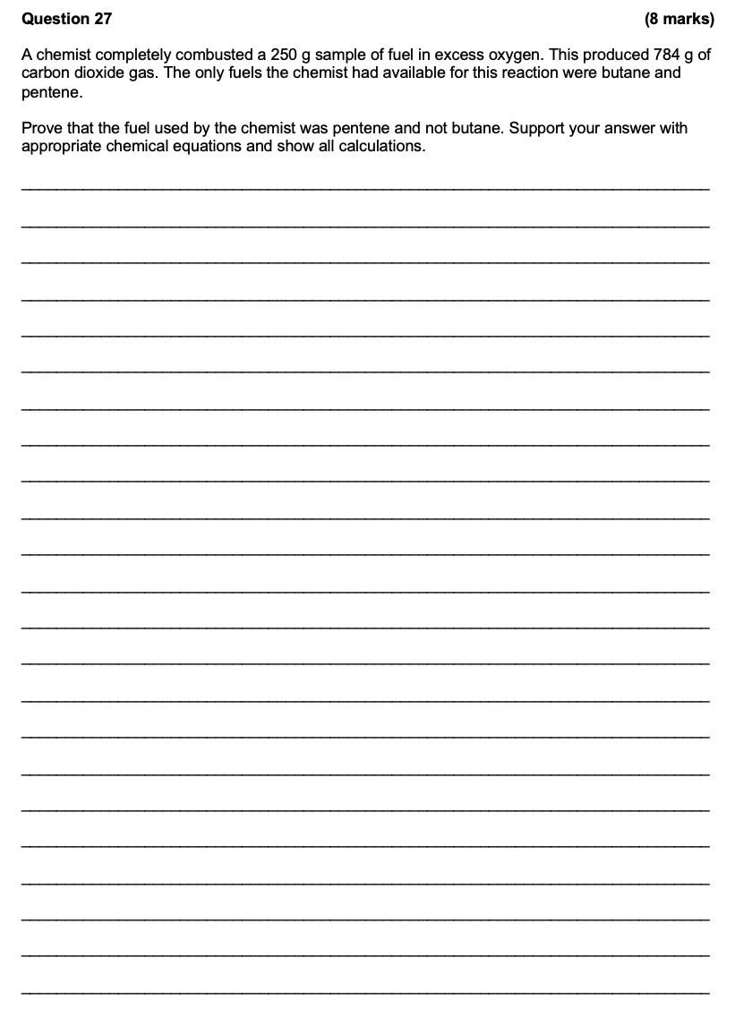

## 2023 S2

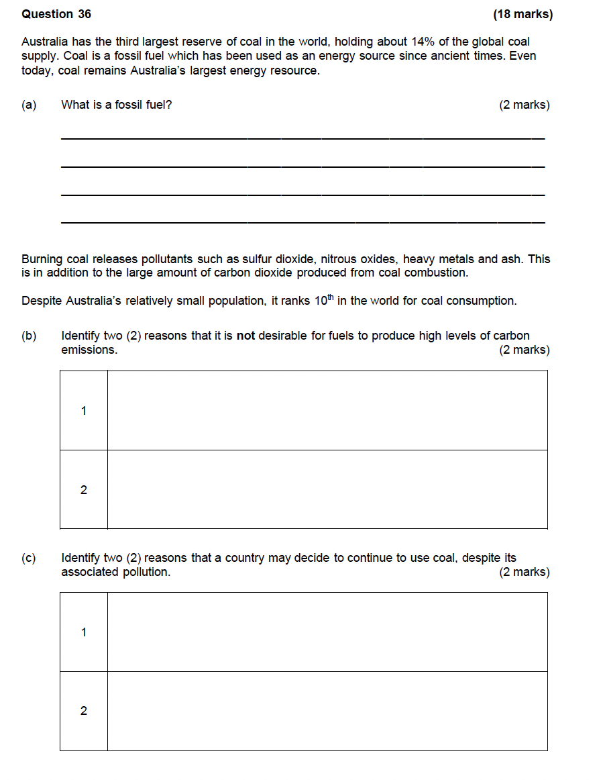

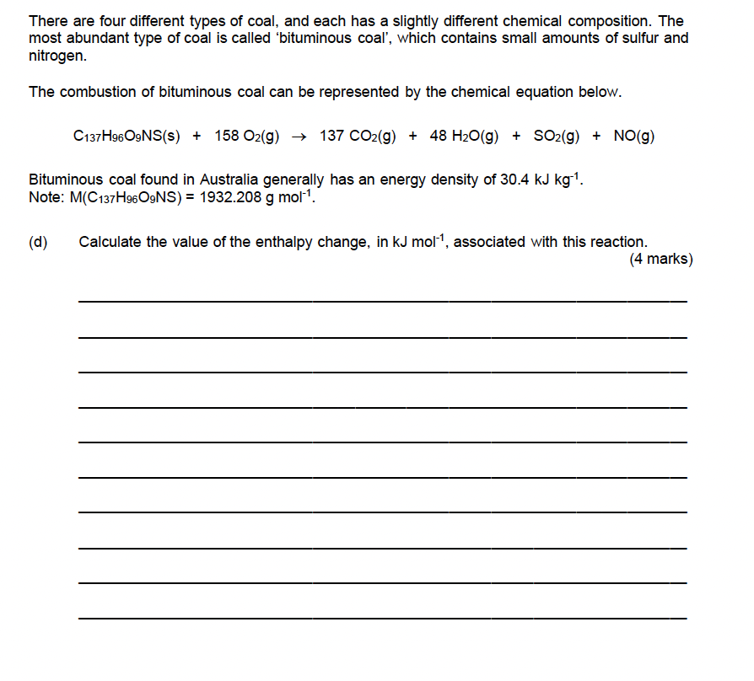

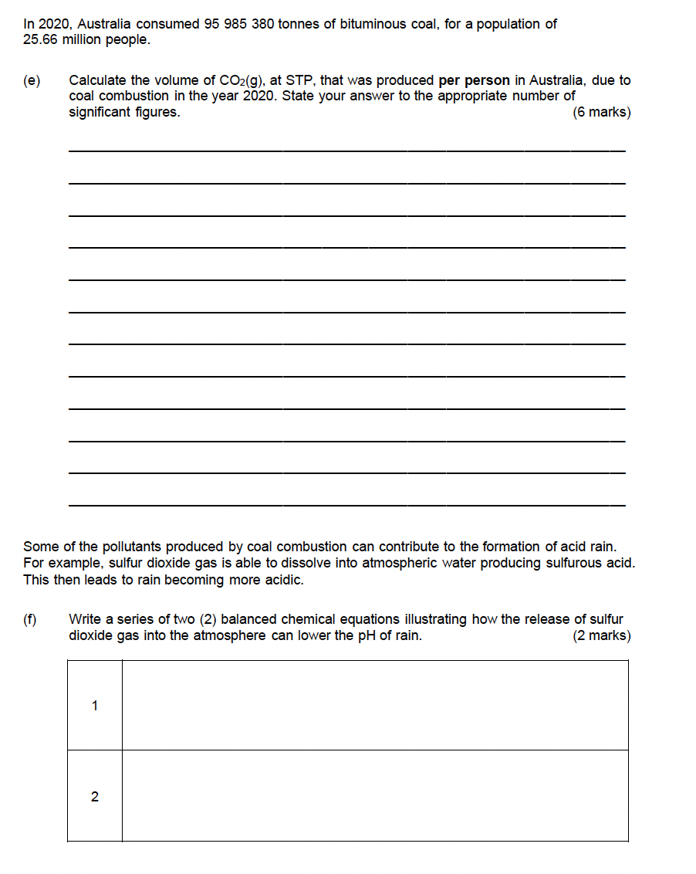

# Other Chemical Reactions

## 2017 S1

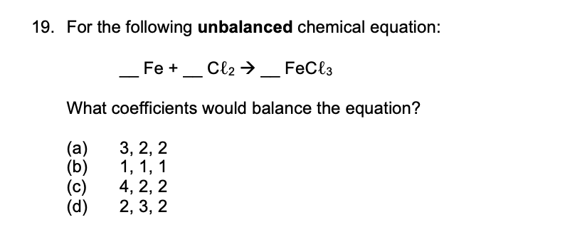

## 2017 S2

## 2020 S1

## 2020 S2

## 2023 S1

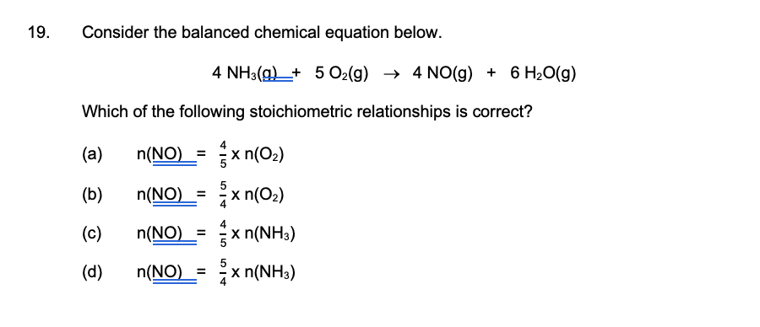

## 2023 S2

